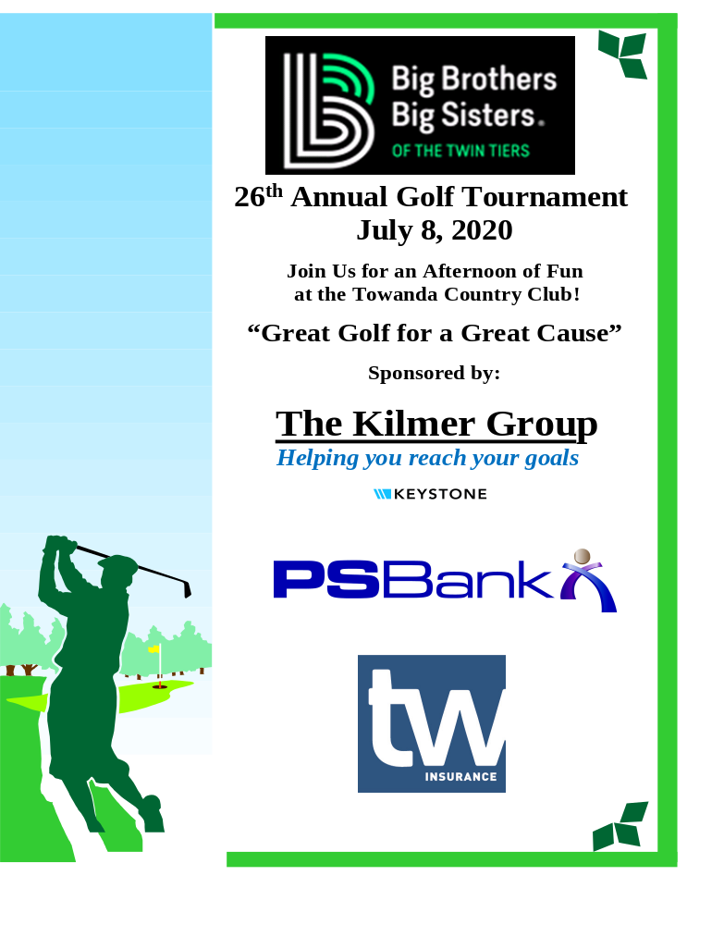
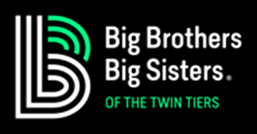 2020 Sponsorship Levels
Call 800.472.8887 for more information
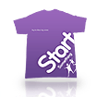 Fund a Perfect Match between a Big & a Little: $1,000
Includes Foursome and their lunches and dinners
Listing on the BBBS Website
Recognition at the meals, at a hole, with a full size ad in event presentations and a Sunday newspaper ad
 Tournament Dinner Sponsor: $750
Includes Foursome and their lunches and dinners
Listing on the BBBS Website
Recognition at the meals, at a hole, with a full size ad in event presentations and a Sunday newspaper ad
 Tournament Lunch Sponsor: $750
Includes Foursome and their lunch and dinner
Recognition at the meals, at a hole, with a full size ad in event presentations and a Sunday newspaper ad
Support a Perfect Match between a Big & a Little: $500
Includes two golfers and their lunches and dinners
Recognition at the meals, at a hole, with a full size ad in event presentations and a Sunday newspaper ad
 Sponsor Our Programs & Train More Volunteers: $250
Recognition at the meals, at a hole, with a full size ad and a Sunday newspaper ad
Other Opportunities:
Corporate Golf Package $ 475
Golfing Foursome $ 360
Individual Golfer $ 90
Hole Sponsor & Full Page Ad $ 150
Half Page Ad $ 85
Donation – You Choose the Amount $ ________

The Kilmer Group Helping you reach your goals

26th Annual “Great Golf For A Great Cause”
Big Brothers Big Sisters Golf Tournament

Wednesday July 8, 2020 at the Towanda Country Club

Time: Registration: 11:15 a.m. to 12:15 p.m. Lunch sponsored by:
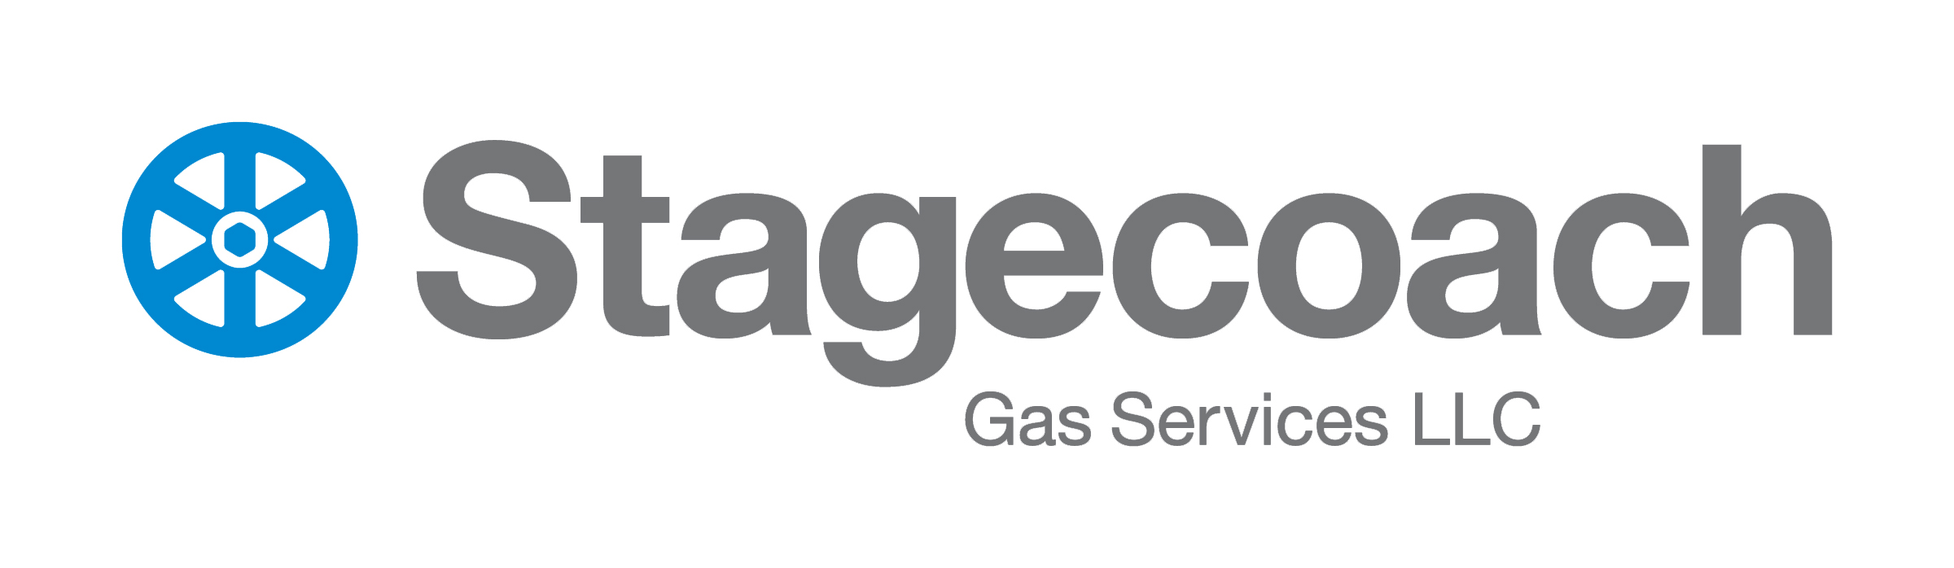
Lunch: 11:30 a.m. Shotgun Start: 12:30 p.m. Rain or Shine
Cocktails: 4:30 p.m. to 5:30 p.m.
Dinner and Awards: 5:30 p.m.
Format: Four Player Scramble

SOFT SPIKES required.

Call 800.472.8887 for more information

Company Name: __________________________________________________________________________

Email address: _________________________________ Contact Phone: ____________________________

Company Address: ________________________________________________________________________

Golfers Names: 1. _____________________________________ 2. ______________________________________
3. _________________________________ 4. __________________________________

How Many Golfers will be staying for dinner? __________________________________________________

Corporate Package: Includes 4 golfers, full size ad in tournament presentations, name at hole, ad in Sunday newspaper, lunch and dinner for four golfers | $475
Foursome Golf Only: Includes 4 golfers, lunch and dinner included | $360
Individual Golfer: Lunch and dinner included | $90
Hole Sponsor & Advertisement: Full size (5” x 7”) ad in tournament presentations, name on hole, ad in Sunday newspaper | $150
Advertisements: Size (5” x 3.5”) ad in tournament presentations, ad in Sunday newspaper | $85
Other Sponsorship Opportunities:

Sorry, I can’t attend. My Donation to BBBS is enclosed

Total Amount Enclosed

Please return this registration form by July 1st with your check made payable to:
BBBS, c/o The Kilmer Group, PO Box 337, Wyalusing, PA 18853
*** Prize donations are greatly appreciated. ***

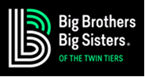

26th Annual “Great Golf for a Great Cause”

Golf Tournament July 8, 2020

ATTENTION SPONSORS & ADVERTISERS

A FULL SIZE AD IS 5 INCHES WIDE X 7 INCHES HIGH - $150

A HALF-SIZE AD IS 5 INCHES WIDE X 3.5 INCHES HIGH - $85
Ads can be printed in color or black and white

PLEASE SUBMIT YOUR AD TO:
The Kilmer Group
PO Box 337
Wyalusing, PA 18853
570-746-1007 or 800-472-8887


You may email your ads to: agency@thekilmergroup.com

PRIZES will be awarded for:

1st and 2nd place in each of three flights
Putting Contest at the turn
Double Down Contest on #4
Pot O’ Gold Contest on # 14
Separate prizes for men and women include:

Closest to the pin on Hole #2, #14, #16
Longest Drive on Hole #9

Most accurate drive on Hole #15

Back by popular demand, Mulligans and Super Tickets will be available!

***YOUR PRIZE DONATIONS ARE GREATLY APPRECIATED***
***

